 | NUTECH  National University of Technology  Department of Computer Science
Assignment # 1
Q #1: Estimate the domain of .
Q #2: The accompanying figure shows the graph of shifted to two new positions. Determine the equations for the new graphs.
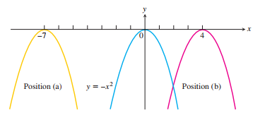
Q #3: Draw the graph for integer floor and ceiling functions and Determine the values of for which and
Q #4: Draw the graph for and use it to interpret the graph of

